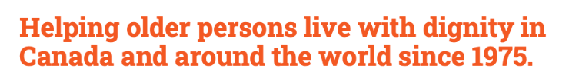
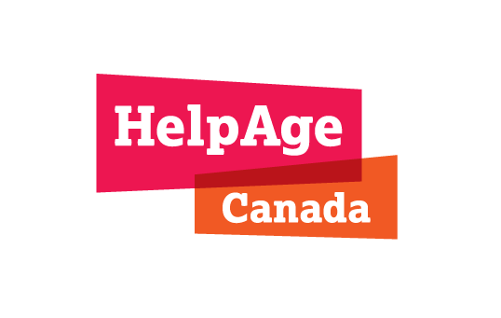

The Role of the CBSS Sector in Addressing Older Women’s Economic Prosperity and Security.

Why This Matters
• Growing aging population in Canada:
- As of July 2025 there are approx. 8.1 million Canadians aged 65+ (12.3 million, 55+), and approx. 4.5 million women in Canada aged 65+/(9.37 million 55+)
- By 2050 25% of the population will be 65+.
- Women aged 55+ years represent more than 51.5% of the population of that age group.
• Older women face greater economic insecurity due to lifelong inequities, chronic illness, caregiving roles, widowhood, and social isolation.
• Almost 90% of Community-Based Seniors’ Services (CBSS) users are older women, and 33%-50% of CBSS workers are women, yet their needs and contributions are often overlooked.
• Social determinants (like income and security) drive 80% of health outcomes.

Our Goal
• To strengthen the economic prosperity and security of older women by working with CBSS organisations, researchers, policymakers, and communities.

How We’ll Do It
• Phase I – Listening & Learning: Consultations, focus groups, and surveys with older women (including racialised women) and CBSS staff/volunteers to identify barriers and lived experiences.
• Phase II – Taking Action: Develop a multi-year CBSS sector strategy, policy recommendations, and host roundtables with policymakers to drive systemic change.
• Phase III – Scaling & Sharing: Nationwide, multilingual consultations and knowledge exchange to spread best practices and strengthen CBSS across Canada.

Equity Lens
• We will prioritize engagement with older adult women 55+ who are from racialized or minority backgrounds, newcomers, immigrants, Indigenous and low income older women, both as service users and as members of the CBSS workforce.
- Meaningful Engagement
  - Older women will be involved at every stage: design, governance, and implementation.
  - Consultations will ensure accessibility and representation from all provinces/territories.

What This Means for CBSS Organisations
• Share local perspectives: Participate in consultations and focus groups.
• Strengthen your voice: Contribute to policy and sector-wide strategies.
• Shape solutions: Ensure older women in your community are heard.
• Benefit from resources: Gain tools, knowledge, and connections to support your programs and staff.

Expected Impact
- Stronger CBSS networks nationwide.
- Better resources and access for older women.
- Sustainable, evidence-based policies.
- Greater gender equity in aging.

Key Partners
• CBSS Organisations – Amplify voices of older women in the community.
• National Institute on Ageing (NIA) – Research and roundtables.
• Academic Leaders (Toronto Metropolitan University, University of Toronto – led by Dr. Samir Sinha).
• Sector Experts – Health, housing, finance, social services.
• Provincial/Territorial Governments – Consultations on regional priorities.

HelpAge Canada is a registered charity with a Canadian focus and global reach, exclusively dedicated to advancing the rights, well-being, and dignity of older people. Since 1975, we’ve partnered with and invested in local communities to improve lives in Canada and beyond. We are working to build a coordinated Pan-Canadian community-based seniors’ services (CBSS) sector, sharing knowledge, setting priorities, and shaping an inclusive vision for the future of ageing. Priority programming, such as Age Better Grants, fund local initiatives by community, for community, to reduce isolation and improve quality of life for older people.
Visit helpagecanada.ca. Follow us on LinkedIn, Instagram, X (formerly Twitter), and Facebook.

